UNITED STATES
SECURITIES AND EXCHANGE COMMISSION
WASHINGTON, D.C. 20549

FORM 8-K

CURRENT REPORT
PURSUANT TO SECTION 13 OR 15(d) OF
THE SECURITIES EXCHANGE ACT OF 1934

Date of Report (Date of Earliest Event Reported): July 30, 2026
Corteva, Inc.
(Exact Name of Registrant as Specified in Its Charter)

Delaware |  |  |  |  |  | 001-38710 |  |  |  |  |  | 82-4979096
(State or other jurisdiction |  |  |  |  |  | (Commission |  |  |  |  |  | (I.R.S. Employer
of Incorporation) |  |  |  |  |  | File Number) |  |  |  |  |  | Identification No.)

9330 Zionsville Road,
Indianapolis, Indiana 46268
1000 N. West Street, Suite 900,
Wilmington, Delaware 19801
(Address of principal executive offices)(Zip Code)

(833) 267-8382
(Registrant’s telephone number, including area code)

Check the appropriate box below if the Form 8-K filing is intended to simultaneously satisfy the filing obligation of the registrant under any of the following provisions:

☐ Written communications pursuant to Rule 425 under the Securities Act (17 CFR 230.425)

☐ Soliciting material pursuant to Rule 14a-12 under the Exchange Act (17 CFR 240.14a-12)

☐ Pre-commencement communications pursuant to Rule 14d-2(b) under the Exchange Act (17 CFR 240.14d-2(b))

☐ Pre-commencement communications pursuant to Rule 13e-4(c) under the Exchange Act (17 CFR 240.13e-4(c))

Securities registered pursuant to Section 12(b) of the Act:
Title of each class |  |  |  |  |  | Trading Symbol(s) |  |  |  |  |  | Name of each exchange on which registered
Common Stock, par value $0.01 per share |  |  |  |  |  | CTVA |  |  |  |  |  | New York Stock Exchange

Indicate by check mark whether the registrant is an emerging growth company as defined in Rule 405 of the Securities Act of 1933 (§230.405 of this chapter) or Rule 12b-2 of the Securities Exchange Act of 1934 (§240.12b-2 of this chapter).

Emerging growth company ☐

If an emerging growth company, indicate by check mark if the registrant has elected not to use the extended transition period for complying with any new or revised financial accounting standards provided pursuant to Section 13(a) of the Exchange Act. o

Item 2.02 Results of Operations and Financial Condition
On July 30, 2026, Corteva, Inc. (the “Company”) announced its consolidated financial results for the quarter ended June 30, 2026. A copy of the Company’s press release and financial statement schedules are furnished herewith on Form 8-K as Exhibits 99.1 and 99.2, respectively. The information contained in this report, including Exhibits 99.1 and 99.2, is being furnished and shall not be deemed “filed” for purposes of Section 18 of the Securities Exchange Act of 1934, as amended (the “Exchange Act”), or otherwise subject to the liability of that section. In addition, the information contained in this report shall not be deemed to be incorporated by reference into any registration statement or other document filed by the Company under the Securities Act of 1933, as amended, or the Exchange Act except as expressly set forth by specific reference in such filing.

Item 9.01 Financial Statements and Exhibits

(d) Exhibits.
99.1 |  |  | Press Release dated July 30, 2026
99.2 |  |  | Financial Statement Schedules dated July 30, 2026
104 |  |  | The cover page from the Company’s Current Report on Form 8-K, formatted in Inline XBRL

SIGNATURE

Pursuant to the requirements of the Securities Exchange Act of 1934, the Registrant has duly caused this report to be signed on its behalf by the undersigned hereunto duly authorized.

Corteva, Inc.
(Registrant)
/s/ Brian Titus
Brian Titus
Vice President and Controller

July 30, 2026

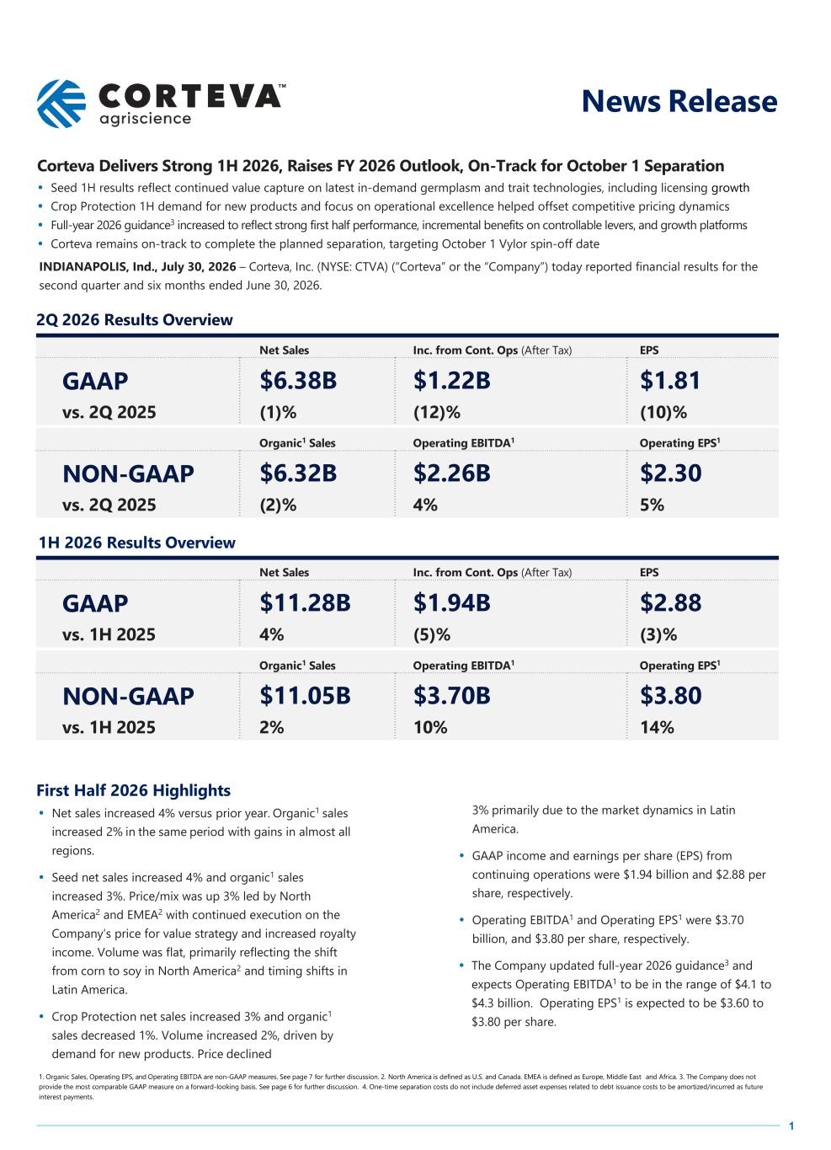

1 News Release Corteva Delivers Strong 1H 2026, Raises FY 2026 Outlook, On-Track for October 1 Separation • Seed 1H results reflect continued value capture on latest in-demand germplasm and trait technologies, including licensing growth • Crop Protection 1H demand for new products and focus on operational excellence helped offset competitive pricing dynamics • Full-year 2026 guidance3 increased to reflect strong first half performance, incremental benefits on controllable levers, and growth platforms • Corteva remains on-track to complete the planned separation, targeting October 1 Vylor spin-off date INDIANAPOLIS, Ind., July 30, 2026 – Corteva, Inc. (NYSE: CTVA) (“Corteva” or the “Company”) today reported financial results for the second quarter and six months ended June 30, 2026. 2Q 2026 Results Overview Net Sales Inc. from Cont. Ops (After Tax) EPS GAAP $6.38B $1.22B $1.81 vs. 2Q 2025 (1)% (12)% (10)% Organic1 Sales Operating EBITDA1 Operating EPS1 NON-GAAP $6.32B $2.26B $2.30 vs. 2Q 2025 (2)% 4% 5% 1H 2026 Results Overview Net Sales Inc. from Cont. Ops (After Tax) EPS GAAP $11.28B $1.94B $2.88 vs. 1H 2025 4% (5)% (3)% Organic1 Sales Operating EBITDA1 Operating EPS1 NON-GAAP $11.05B $3.70B $3.80 vs. 1H 2025 2% 10% 14% First Half 2026 Highlights • Net sales increased 4% versus prior year. Organic1 sales increased 2% in the same period with gains in almost all regions. • Seed net sales increased 4% and organic1 sales increased 3%. Price/mix was up 3% led by North America2 and EMEA2 with continued execution on the Company’s price for value strategy and increased royalty income. Volume was flat, primarily reflecting the shift from corn to soy in North America2 and timing shifts in Latin America. • Crop Protection net sales increased 3% and organic1 sales decreased 1%. Volume increased 2%, driven by demand for new products. Price declined 3% primarily due to the market dynamics in Latin America. • GAAP income and earnings per share (EPS) from continuing operations were $1.94 billion and $2.88 per share, respectively. • Operating EBITDA1 and Operating EPS1 were $3.70 billion, and $3.80 per share, respectively. • The Company updated full-year 2026 guidance3 and expects Operating EBITDA1 to be in the range of $4.1 to $4.3 billion. Operating EPS1 is expected to be $3.60 to $3.80 per share. 1. Organic Sales, Operating EPS, and Operating EBITDA are non-GAAP measures. See page 7 for further discussion. 2. North America is defined as U.S. and Canada. EMEA is defined as Europe, Middle East and Africa. 3. The Company does not provide the most comparable GAAP measure on a forward-looking basis. See page 6 for further discussion. 4. One-time separation costs do not include deferred asset expenses related to debt issuance costs to be amortized/incurred as future interest payments.

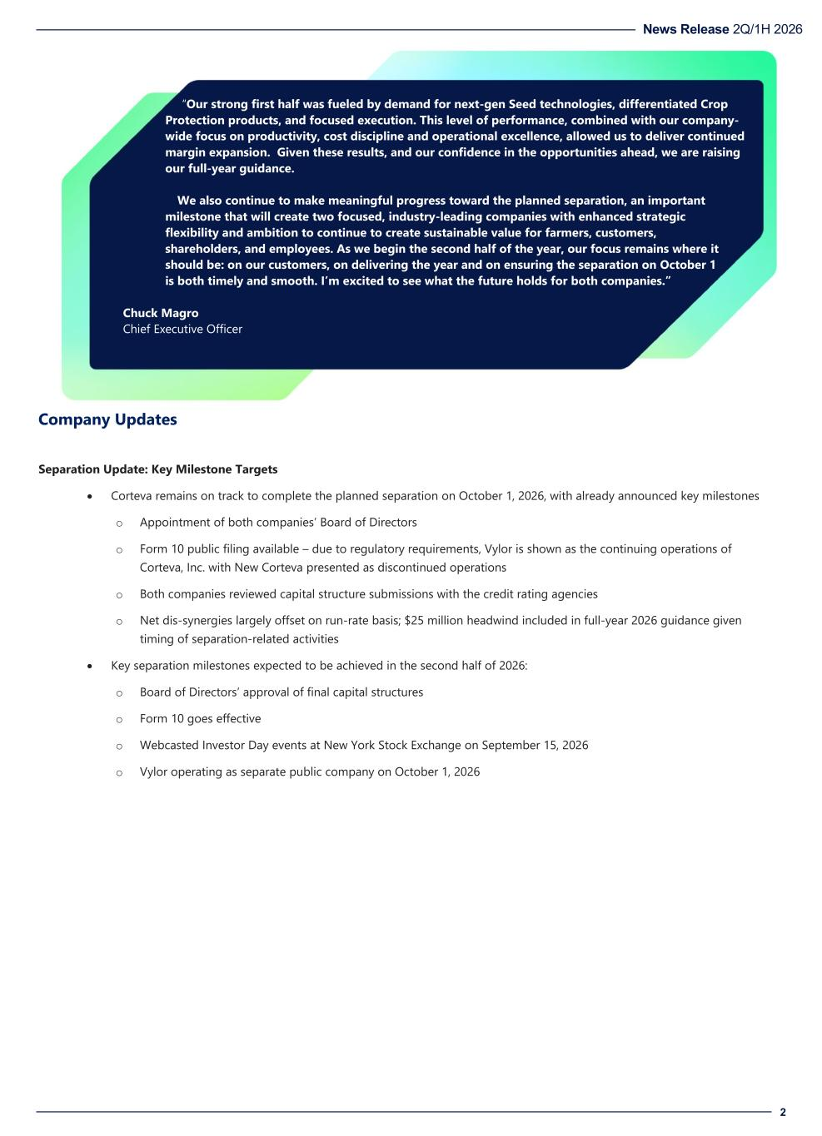
News Release 2Q/1H 2026 2 “Our strong first half was fueled by demand for next-gen Seed technologies, differentiated Crop Protection products, and focused execution. This level of performance, combined with our company- wide focus on productivity, cost discipline and operational excellence, allowed us to deliver continued margin expansion. Given these results, and our confidence in the opportunities ahead, we are raising our full-year guidance. We also continue to make meaningful progress toward the planned separation, an important milestone that will create two focused, industry-leading companies with enhanced strategic flexibility and ambition to continue to create sustainable value for farmers, customers, shareholders, and employees. As we begin the second half of the year, our focus remains where it should be: on our customers, on delivering the year and on ensuring the separation on October 1 is both timely and smooth. I’m excited to see what the future holds for both companies.” Chuck Magro Chief Executive Officer Company Updates Separation Update: Key Milestone Targets • Corteva remains on track to complete the planned separation on October 1, 2026, with already announced key milestones o Appointment of both companies’ Board of Directors o Form 10 public filing available – due to regulatory requirements, Vylor is shown as the continuing operations of Corteva, Inc. with New Corteva presented as discontinued operations o Both companies reviewed capital structure submissions with the credit rating agencies o Net dis-synergies largely offset on run-rate basis; $25 million headwind included in full-year 2026 guidance given timing of separation-related activities • Key separation milestones expected to be achieved in the second half of 2026: o Board of Directors’ approval of final capital structures o Form 10 goes effective o Webcasted Investor Day events at New York Stock Exchange on September 15, 2026 o Vylor operating as separate public company on October 1, 2026

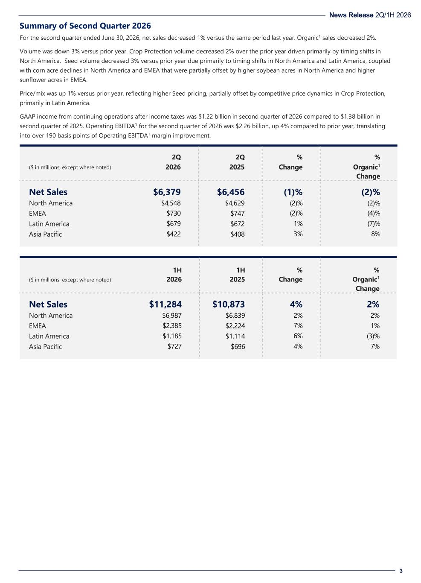
News Release 2Q/1H 2026 3 Summary of Second Quarter 2026 For the second quarter ended June 30, 2026, net sales decreased 1% versus the same period last year. Organic1 sales decreased 2%. Volume was down 3% versus prior year. Crop Protection volume decreased 2% over the prior year driven primarily by timing shifts in North America. Seed volume decreased 3% versus prior year due primarily to timing shifts in North America and Latin America, coupled with corn acre declines in North America and EMEA that were partially offset by higher soybean acres in North America and higher sunflower acres in EMEA. Price/mix was up 1% versus prior year, reflecting higher Seed pricing, partially offset by competitive price dynamics in Crop Protection, primarily in Latin America. GAAP income from continuing operations after income taxes was $1.22 billion in second quarter of 2026 compared to $1.38 billion in second quarter of 2025. Operating EBITDA1 for the second quarter of 2026 was $2.26 billion, up 4% compared to prior year, translating into over 190 basis points of Operating EBITDA1 margin improvement. 2Q 2Q % % ($ in millions, except where noted) 2026 2025 Change Organic1 Change Net Sales $6,379 $6,456 (1)% (2)% North America $4,548 $4,629 (2)% (2)% EMEA $730 $747 (2)% (4)% Latin America $679 $672 1% (7)% Asia Pacific $422 $408 3% 8% 1H 1H % % ($ in millions, except where noted) 2026 2025 Change Organic1 Change Net Sales $11,284 $10,873 4% 2% North America $6,987 $6,839 2% 2% EMEA $2,385 $2,224 7% 1% Latin America $1,185 $1,114 6% (3)% Asia Pacific $727 $696 4% 7%

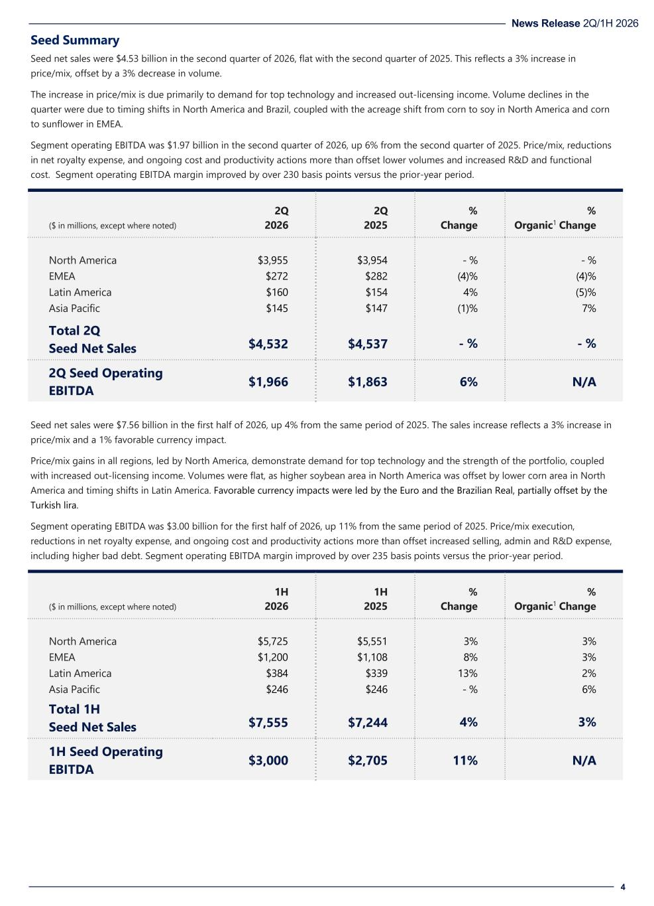
News Release 2Q/1H 2026 4 Seed Summary Seed net sales were $4.53 billion in the second quarter of 2026, flat with the second quarter of 2025. This reflects a 3% increase in price/mix, offset by a 3% decrease in volume. The increase in price/mix is due primarily to demand for top technology and increased out-licensing income. Volume declines in the quarter were due to timing shifts in North America and Brazil, coupled with the acreage shift from corn to soy in North America and corn to sunflower in EMEA. Segment operating EBITDA was $1.97 billion in the second quarter of 2026, up 6% from the second quarter of 2025. Price/mix, reductions in net royalty expense, and ongoing cost and productivity actions more than offset lower volumes and increased R&D and functional cost. Segment operating EBITDA margin improved by over 230 basis points versus the prior-year period. 2Q 2Q % % ($ in millions, except where noted) 2026 2025 Change Organic1 Change North America $3,955 $3,954 - % - % EMEA $272 $282 (4)% (4)% Latin America $160 $154 4% (5)% Asia Pacific $145 $147 (1)% 7% Total 2Q Seed Net Sales $4,532 $4,537 - % - % 2Q Seed Operating EBITDA $1,966 $1,863 6% N/A Seed net sales were $7.56 billion in the first half of 2026, up 4% from the same period of 2025. The sales increase reflects a 3% increase in price/mix and a 1% favorable currency impact. Price/mix gains in all regions, led by North America, demonstrate demand for top technology and the strength of the portfolio, coupled with increased out-licensing income. Volumes were flat, as higher soybean area in North America was offset by lower corn area in North America and timing shifts in Latin America. Favorable currency impacts were led by the Euro and the Brazilian Real, partially offset by the Turkish lira. Segment operating EBITDA was $3.00 billion for the first half of 2026, up 11% from the same period of 2025. Price/mix execution, reductions in net royalty expense, and ongoing cost and productivity actions more than offset increased selling, admin and R&D expense, including higher bad debt. Segment operating EBITDA margin improved by over 235 basis points versus the prior-year period. 1H 1H % % ($ in millions, except where noted) 2026 2025 Change Organic1 Change North America $5,725 $5,551 3% 3% EMEA $1,200 $1,108 8% 3% Latin America $384 $339 13% 2% Asia Pacific $246 $246 - % 6% Total 1H Seed Net Sales $7,555 $7,244 4% 3% 1H Seed Operating EBITDA $3,000 $2,705 11% N/A

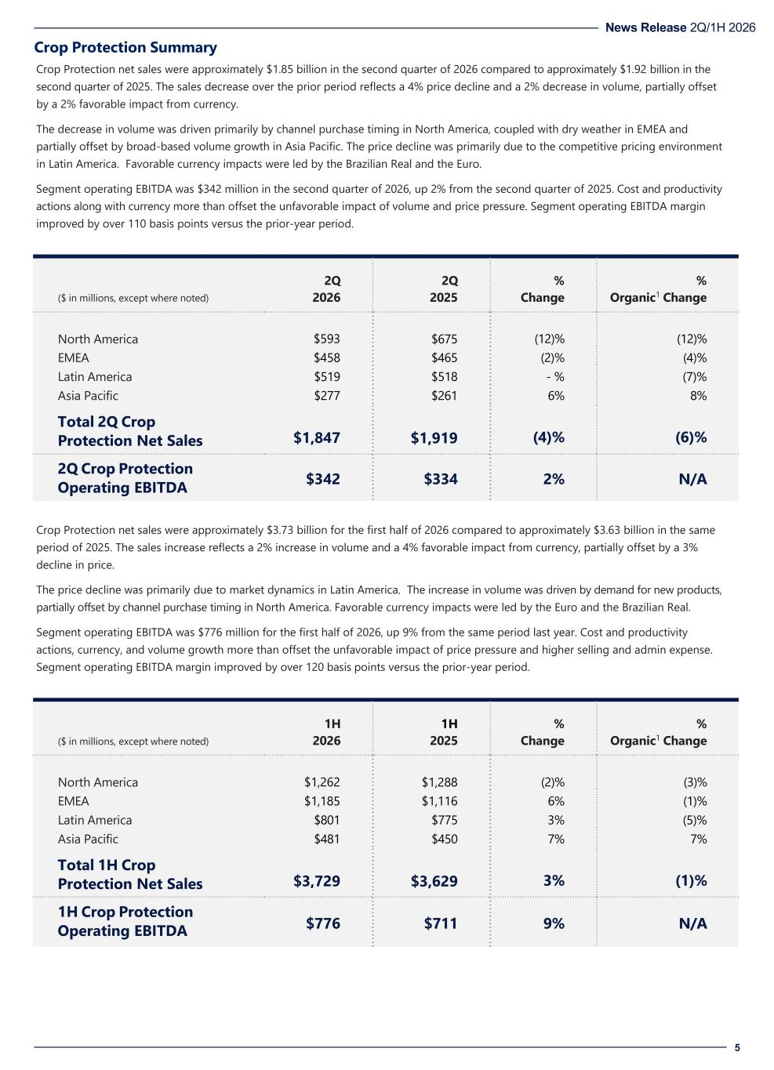
News Release 2Q/1H 2026 5 Crop Protection Summary Crop Protection net sales were approximately $1.85 billion in the second quarter of 2026 compared to approximately $1.92 billion in the second quarter of 2025. The sales decrease over the prior period reflects a 4% price decline and a 2% decrease in volume, partially offset by a 2% favorable impact from currency. The decrease in volume was driven primarily by channel purchase timing in North America, coupled with dry weather in EMEA and partially offset by broad-based volume growth in Asia Pacific. The price decline was primarily due to the competitive pricing environment in Latin America. Favorable currency impacts were led by the Brazilian Real and the Euro. Segment operating EBITDA was $342 million in the second quarter of 2026, up 2% from the second quarter of 2025. Cost and productivity actions along with currency more than offset the unfavorable impact of volume and price pressure. Segment operating EBITDA margin improved by over 110 basis points versus the prior-year period. 2Q 2Q % % ($ in millions, except where noted) 2026 2025 Change Organic1 Change North America $593 $675 (12)% (12)% EMEA $458 $465 (2)% (4)% Latin America $519 $518 - % (7)% Asia Pacific $277 $261 6% 8% Total 2Q Crop Protection Net Sales $1,847 $1,919 (4)% (6)% 2Q Crop Protection Operating EBITDA $342 $334 2% N/A Crop Protection net sales were approximately $3.73 billion for the first half of 2026 compared to approximately $3.63 billion in the same period of 2025. The sales increase reflects a 2% increase in volume and a 4% favorable impact from currency, partially offset by a 3% decline in price. The price decline was primarily due to market dynamics in Latin America. The increase in volume was driven by demand for new products, partially offset by channel purchase timing in North America. Favorable currency impacts were led by the Euro and the Brazilian Real. Segment operating EBITDA was $776 million for the first half of 2026, up 9% from the same period last year. Cost and productivity actions, currency, and volume growth more than offset the unfavorable impact of price pressure and higher selling and admin expense. Segment operating EBITDA margin improved by over 120 basis points versus the prior-year period. 1H 1H % % ($ in millions, except where noted) 2026 2025 Change Organic1 Change North America $1,262 $1,288 (2)% (3)% EMEA $1,185 $1,116 6% (1)% Latin America $801 $775 3% (5)% Asia Pacific $481 $450 7% 7% Total 1H Crop Protection Net Sales $3,729 $3,629 3% (1)% 1H Crop Protection Operating EBITDA $776 $711 9% N/A

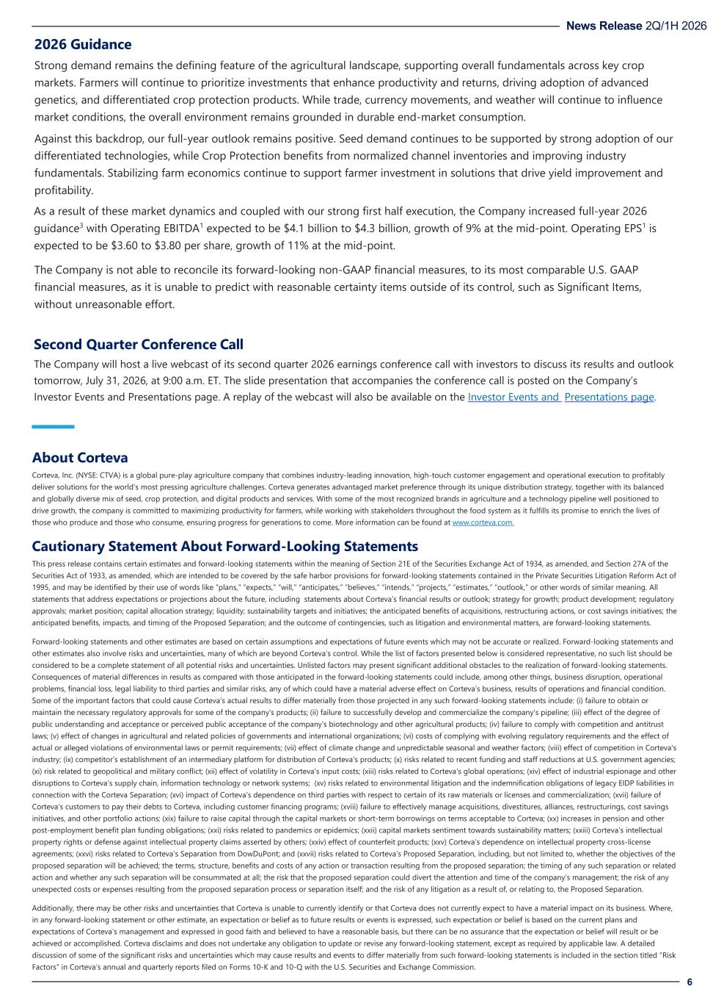
News Release 2Q/1H 2026 6 2026 Guidance Strong demand remains the defining feature of the agricultural landscape, supporting overall fundamentals across key crop markets. Farmers will continue to prioritize investments that enhance productivity and returns, driving adoption of advanced genetics, and differentiated crop protection products. While trade, currency movements, and weather will continue to influence market conditions, the overall environment remains grounded in durable end-market consumption. Against this backdrop, our full-year outlook remains positive. Seed demand continues to be supported by strong adoption of our differentiated technologies, while Crop Protection benefits from normalized channel inventories and improving industry fundamentals. Stabilizing farm economics continue to support farmer investment in solutions that drive yield improvement and profitability. As a result of these market dynamics and coupled with our strong first half execution, the Company increased full-year 2026 guidance3 with Operating EBITDA1 expected to be $4.1 billion to $4.3 billion, growth of 9% at the mid-point. Operating EPS1 is expected to be $3.60 to $3.80 per share, growth of 11% at the mid-point. The Company is not able to reconcile its forward-looking non-GAAP financial measures, to its most comparable U.S. GAAP financial measures, as it is unable to predict with reasonable certainty items outside of its control, such as Significant Items, without unreasonable effort. Second Quarter Conference Call The Company will host a live webcast of its second quarter 2026 earnings conference call with investors to discuss its results and outlook tomorrow, July 31, 2026, at 9:00 a.m. ET. The slide presentation that accompanies the conference call is posted on the Company’s Investor Events and Presentations page. A replay of the webcast will also be available on the Investor Events and Presentations page. About Corteva Corteva, Inc. (NYSE: CTVA) is a global pure-play agriculture company that combines industry-leading innovation, high-touch customer engagement and operational execution to profitably deliver solutions for the world’s most pressing agriculture challenges. Corteva generates advantaged market preference through its unique distribution strategy, together with its balanced and globally diverse mix of seed, crop protection, and digital products and services. With some of the most recognized brands in agriculture and a technology pipeline well positioned to drive growth, the company is committed to maximizing productivity for farmers, while working with stakeholders throughout the food system as it fulfills its promise to enrich the lives of those who produce and those who consume, ensuring progress for generations to come. More information can be found at www.corteva.com. Cautionary Statement About Forward-Looking Statements This press release contains certain estimates and forward-looking statements within the meaning of Section 21E of the Securities Exchange Act of 1934, as amended, and Section 27A of the Securities Act of 1933, as amended, which are intended to be covered by the safe harbor provisions for forward-looking statements contained in the Private Securities Litigation Reform Act of 1995, and may be identified by their use of words like “plans,” “expects,” “will,” “anticipates,” “believes,” “intends,” “projects,” “estimates,” “outlook,” or other words of similar meaning. All statements that address expectations or projections about the future, including statements about Corteva’s financial results or outlook; strategy for growth; product development; regulatory approvals; market position; capital allocation strategy; liquidity; sustainability targets and initiatives; the anticipated benefits of acquisitions, restructuring actions, or cost savings initiatives; the anticipated benefits, impacts, and timing of the Proposed Separation; and the outcome of contingencies, such as litigation and environmental matters, are forward-looking statements. Forward-looking statements and other estimates are based on certain assumptions and expectations of future events which may not be accurate or realized. Forward-looking statements and other estimates also involve risks and uncertainties, many of which are beyond Corteva’s control. While the list of factors presented below is considered representative, no such list should be considered to be a complete statement of all potential risks and uncertainties. Unlisted factors may present significant additional obstacles to the realization of forward-looking statements. Consequences of material differences in results as compared with those anticipated in the forward-looking statements could include, among other things, business disruption, operational problems, financial loss, legal liability to third parties and similar risks, any of which could have a material adverse effect on Corteva’s business, results of operations and financial condition. Some of the important factors that could cause Corteva’s actual results to differ materially from those projected in any such forward-looking statements include: (i) failure to obtain or maintain the necessary regulatory approvals for some of the company's products; (ii) failure to successfully develop and commercialize the company's pipeline; (iii) effect of the degree of public understanding and acceptance or perceived public acceptance of the company's biotechnology and other agricultural products; (iv) failure to comply with competition and antitrust laws; (v) effect of changes in agricultural and related policies of governments and international organizations; (vi) costs of complying with evolving regulatory requirements and the effect of actual or alleged violations of environmental laws or permit requirements; (vii) effect of climate change and unpredictable seasonal and weather factors; (viii) effect of competition in Corteva's industry; (ix) competitor’s establishment of an intermediary platform for distribution of Corteva's products; (x) risks related to recent funding and staff reductions at U.S. government agencies; (xi) risk related to geopolitical and military conflict; (xii) effect of volatility in Corteva's input costs; (xiii) risks related to Corteva's global operations; (xiv) effect of industrial espionage and other disruptions to Corteva’s supply chain, information technology or network systems; (xv) risks related to environmental litigation and the indemnification obligations of legacy EIDP liabilities in connection with the Corteva Separation; (xvi) impact of Corteva's dependence on third parties with respect to certain of its raw materials or licenses and commercialization; (xvii) failure of Corteva’s customers to pay their debts to Corteva, including customer financing programs; (xviii) failure to effectively manage acquisitions, divestitures, alliances, restructurings, cost savings initiatives, and other portfolio actions; (xix) failure to raise capital through the capital markets or short-term borrowings on terms acceptable to Corteva; (xx) increases in pension and other post-employment benefit plan funding obligations; (xxi) risks related to pandemics or epidemics; (xxii) capital markets sentiment towards sustainability matters; (xxiii) Corteva’s intellectual property rights or defense against intellectual property claims asserted by others; (xxiv) effect of counterfeit products; (xxv) Corteva’s dependence on intellectual property cross-license agreements; (xxvi) risks related to Corteva’s Separation from DowDuPont; and (xxvii) risks related to Corteva’s Proposed Separation, including, but not limited to, whether the objectives of the proposed separation will be achieved; the terms, structure, benefits and costs of any action or transaction resulting from the proposed separation; the timing of any such separation or related action and whether any such separation will be consummated at all; the risk that the proposed separation could divert the attention and time of the company’s management; the risk of any unexpected costs or expenses resulting from the proposed separation process or separation itself; and the risk of any litigation as a result of, or relating to, the Proposed Separation. Additionally, there may be other risks and uncertainties that Corteva is unable to currently identify or that Corteva does not currently expect to have a material impact on its business. Where, in any forward-looking statement or other estimate, an expectation or belief as to future results or events is expressed, such expectation or belief is based on the current plans and expectations of Corteva’s management and expressed in good faith and believed to have a reasonable basis, but there can be no assurance that the expectation or belief will result or be achieved or accomplished. Corteva disclaims and does not undertake any obligation to update or revise any forward-looking statement, except as required by applicable law. A detailed discussion of some of the significant risks and uncertainties which may cause results and events to differ materially from such forward-looking statements is included in the section titled “Risk Factors” in Corteva’s annual and quarterly reports filed on Forms 10-K and 10-Q with the U.S. Securities and Exchange Commission.

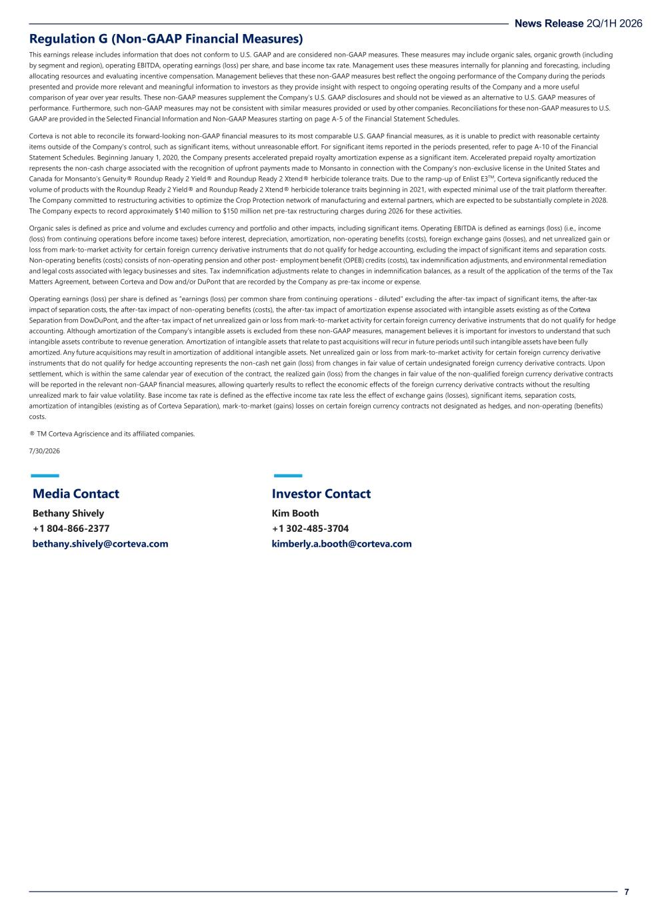
News Release 2Q/1H 2026 7 Regulation G (Non-GAAP Financial Measures) This earnings release includes information that does not conform to U.S. GAAP and are considered non-GAAP measures. These measures may include organic sales, organic growth (including by segment and region), operating EBITDA, operating earnings (loss) per share, and base income tax rate. Management uses these measures internally for planning and forecasting, including allocating resources and evaluating incentive compensation. Management believes that these non-GAAP measures best reflect the ongoing performance of the Company during the periods presented and provide more relevant and meaningful information to investors as they provide insight with respect to ongoing operating results of the Company and a more useful comparison of year over year results. These non-GAAP measures supplement the Company’s U.S. GAAP disclosures and should not be viewed as an alternative to U.S. GAAP measures of performance. Furthermore, such non-GAAP measures may not be consistent with similar measures provided or used by other companies. Reconciliations for these non-GAAP measures to U.S. GAAP are provided in the Selected Financial Information and Non-GAAP Measures starting on page A-5 of the Financial Statement Schedules. Corteva is not able to reconcile its forward-looking non-GAAP financial measures to its most comparable U.S. GAAP financial measures, as it is unable to predict with reasonable certainty items outside of the Company’s control, such as significant items, without unreasonable effort. For significant items reported in the periods presented, refer to page A-10 of the Financial Statement Schedules. Beginning January 1, 2020, the Company presents accelerated prepaid royalty amortization expense as a significant item. Accelerated prepaid royalty amortization represents the non-cash charge associated with the recognition of upfront payments made to Monsanto in connection with the Company’s non-exclusive license in the United States and Canada for Monsanto’s Genuity® Roundup Ready 2 Yield® and Roundup Ready 2 Xtend® herbicide tolerance traits. Due to the ramp-up of Enlist E3TM, Corteva significantly reduced the volume of products with the Roundup Ready 2 Yield® and Roundup Ready 2 Xtend® herbicide tolerance traits beginning in 2021, with expected minimal use of the trait platform thereafter. The Company committed to restructuring activities to optimize the Crop Protection network of manufacturing and external partners, which are expected to be substantially complete in 2028. The Company expects to record approximately $140 million to $150 million net pre-tax restructuring charges during 2026 for these activities. Organic sales is defined as price and volume and excludes currency and portfolio and other impacts, including significant items. Operating EBITDA is defined as earnings (loss) (i.e., income (loss) from continuing operations before income taxes) before interest, depreciation, amortization, non-operating benefits (costs), foreign exchange gains (losses), and net unrealized gain or loss from mark-to-market activity for certain foreign currency derivative instruments that do not qualify for hedge accounting, excluding the impact of significant items and separation costs. Non-operating benefits (costs) consists of non-operating pension and other post- employment benefit (OPEB) credits (costs), tax indemnification adjustments, and environmental remediation and legal costs associated with legacy businesses and sites. Tax indemnification adjustments relate to changes in indemnification balances, as a result of the application of the terms of the Tax Matters Agreement, between Corteva and Dow and/or DuPont that are recorded by the Company as pre-tax income or expense. Operating earnings (loss) per share is defined as “earnings (loss) per common share from continuing operations - diluted” excluding the after-tax impact of significant items, the after-tax impact of separation costs, the after-tax impact of non-operating benefits (costs), the after-tax impact of amortization expense associated with intangible assets existing as of the Corteva Separation from DowDuPont, and the after-tax impact of net unrealized gain or loss from mark-to-market activity for certain foreign currency derivative instruments that do not qualify for hedge accounting. Although amortization of the Company’s intangible assets is excluded from these non-GAAP measures, management believes it is important for investors to understand that such intangible assets contribute to revenue generation. Amortization of intangible assets that relate to past acquisitions will recur in future periods until such intangible assets have been fully amortized. Any future acquisitions may result in amortization of additional intangible assets. Net unrealized gain or loss from mark-to-market activity for certain foreign currency derivative instruments that do not qualify for hedge accounting represents the non-cash net gain (loss) from changes in fair value of certain undesignated foreign currency derivative contracts. Upon settlement, which is within the same calendar year of execution of the contract, the realized gain (loss) from the changes in fair value of the non-qualified foreign currency derivative contracts will be reported in the relevant non-GAAP financial measures, allowing quarterly results to reflect the economic effects of the foreign currency derivative contracts without the resulting unrealized mark to fair value volatility. Base income tax rate is defined as the effective income tax rate less the effect of exchange gains (losses), significant items, separation costs, amortization of intangibles (existing as of Corteva Separation), mark-to-market (gains) losses on certain foreign currency contracts not designated as hedges, and non-operating (benefits) costs. ® TM Corteva Agriscience and its affiliated companies. 7/30/2026 Media Contact Bethany Shively +1 804-866-2377 bethany.shively@corteva.com Investor Contact Kim Booth +1 302-485-3704 kimberly.a.booth@corteva.com

A-1
Corteva, Inc.
Consolidated Statements of Operations
(Dollars in millions, except per share amounts)
 |  |  | Three Months Ended  June 30, |  |  |  |  |  |  |  |  |  |  |  | Six Months Ended  June 30,
 |  |  | 2026 |  |  |  |  |  | 2025 |  |  |  |  |  | 2026 |  |  |  |  |  | 2025
Net sales |  |  | $ | 6,379 |  |  |  |  | $ | 6,456 |  |  |  |  | $ | 11,284 |  |  |  |  | $ | 10,873
Cost of goods sold |  |  | 2,718 |  |  |  |  |  | 2,932 |  |  |  |  |  | 5,090 |  |  |  |  |  | 5,274
Research and development expense |  |  | 388 |  |  |  |  |  | 375 |  |  |  |  |  | 729 |  |  |  |  |  | 710
Selling, general and administrative expenses |  |  | 1,164 |  |  |  |  |  | 1,156 |  |  |  |  |  | 2,041 |  |  |  |  |  | 1,907
Amortization of intangibles |  |  | 194 |  |  |  |  |  | 161 |  |  |  |  |  | 354 |  |  |  |  |  | 323
Restructuring and asset related charges - net |  |  | 49 |  |  |  |  |  | 79 |  |  |  |  |  | 141 |  |  |  |  |  | 101
Separation costs |  |  | 79 |  |  |  |  |  | — |  |  |  |  |  | 131 |  |  |  |  |  | —
Other income (expense) - net |  |  | (115) |  |  |  |  |  | 103 |  |  |  |  |  | (232) |  |  |  |  |  | 118
Interest expense |  |  | 47 |  |  |  |  |  | 52 |  |  |  |  |  | 83 |  |  |  |  |  | 88
Income (loss) from continuing operations before income taxes |  |  | 1,625 |  |  |  |  |  | 1,804 |  |  |  |  |  | 2,483 |  |  |  |  |  | 2,588
Provision for (benefit from) income taxes on continuing operations |  |  | 408 |  |  |  |  |  | 422 |  |  |  |  |  | 541 |  |  |  |  |  | 539
Income (loss) from continuing operations after income taxes |  |  | 1,217 |  |  |  |  |  | 1,382 |  |  |  |  |  | 1,942 |  |  |  |  |  | 2,049
Income (loss) from discontinued operations after income taxes |  |  | (52) |  |  |  |  |  | (66) |  |  |  |  |  | (54) |  |  |  |  |  | (77)
Net income (loss) |  |  | 1,165 |  |  |  |  |  | 1,316 |  |  |  |  |  | 1,888 |  |  |  |  |  | 1,972
Net income (loss) attributable to noncontrolling interests |  |  | 4 |  |  |  |  |  | 2 |  |  |  |  |  | 7 |  |  |  |  |  | 6
Net income (loss) attributable to Corteva |  |  | $ | 1,161 |  |  |  |  | $ | 1,314 |  |  |  |  | $ | 1,881 |  |  |  |  | $ | 1,966
Basic earnings (loss) per share of common stock:
Basic earnings (loss) per share of common stock from continuing operations |  |  | $ | 1.81 |  |  |  |  | $ | 2.02 |  |  |  |  | $ | 2.89 |  |  |  |  | $ | 2.99
Basic earnings (loss) per share of common stock from discontinued operations |  |  | (0.08) |  |  |  |  |  | (0.10) |  |  |  |  |  | (0.08) |  |  |  |  |  | (0.11)
Basic earnings (loss) per share of common stock |  |  | $ | 1.73 |  |  |  |  | $ | 1.92 |  |  |  |  | $ | 2.81 |  |  |  |  | $ | 2.88
Diluted earnings (loss) per share of common stock:
Diluted earnings (loss) per share of common stock from continuing operations |  |  | $ | 1.81 |  |  |  |  | $ | 2.02 |  |  |  |  | $ | 2.88 |  |  |  |  | $ | 2.98
Diluted earnings (loss) per share of common stock from discontinued operations |  |  | (0.08) |  |  |  |  |  | (0.10) |  |  |  |  |  | (0.08) |  |  |  |  |  | (0.11)
Diluted earnings (loss) per share of common stock |  |  | $ | 1.73 |  |  |  |  | $ | 1.92 |  |  |  |  | $ | 2.80 |  |  |  |  | $ | 2.87
Average number of shares outstanding used in earnings (loss) per share (EPS) calculation (in millions)
Basic |  |  | 668.6 |  |  |  |  |  | 681.7 |  |  |  |  |  | 670.4 |  |  |  |  |  | 683.3
Diluted |  |  | 669.8 |  |  |  |  |  | 683.1 |  |  |  |  |  | 671.6 |  |  |  |  |  | 684.7

A-2

Corteva, Inc.
Consolidated Balance Sheets
(Dollars in millions, except share amounts)
 |  |  |  |  |  | June 30, 2026 |  |  |  |  |  | December 31, 2025 |  |  |  |  |  | June 30, 2025
Assets
Current assets
Cash and cash equivalents |  |  |  |  |  | $ | 2,365 |  |  |  |  | $ | 4,521 |  |  |  |  | $ | 2,065
Marketable securities |  |  |  |  |  | — |  |  |  |  |  | 9 |  |  |  |  |  | 76
Accounts and notes receivable - net |  |  |  |  |  | 8,696 |  |  |  |  |  | 6,371 |  |  |  |  |  | 8,674
Inventories |  |  |  |  |  | 4,443 |  |  |  |  |  | 5,667 |  |  |  |  |  | 4,316
Other current assets |  |  |  |  |  | 853 |  |  |  |  |  | 767 |  |  |  |  |  | 873
Total current assets |  |  |  |  |  | 16,357 |  |  |  |  |  | 17,335 |  |  |  |  |  | 16,004
Investment in nonconsolidated affiliates |  |  |  |  |  | 145 |  |  |  |  |  | 160 |  |  |  |  |  | 134
Property, plant and equipment |  |  |  |  |  | 9,744 |  |  |  |  |  | 9,551 |  |  |  |  |  | 9,455
Less: Accumulated depreciation |  |  |  |  |  | 5,566 |  |  |  |  |  | 5,331 |  |  |  |  |  | 5,302
Net property, plant and equipment |  |  |  |  |  | 4,178 |  |  |  |  |  | 4,220 |  |  |  |  |  | 4,153
Goodwill |  |  |  |  |  | 10,437 |  |  |  |  |  | 10,465 |  |  |  |  |  | 10,518
Other intangible assets |  |  |  |  |  | 8,006 |  |  |  |  |  | 8,301 |  |  |  |  |  | 8,583
Deferred income taxes |  |  |  |  |  | 335 |  |  |  |  |  | 320 |  |  |  |  |  | 449
Other assets |  |  |  |  |  | 2,184 |  |  |  |  |  | 2,044 |  |  |  |  |  | 1,918
Total Assets |  |  |  |  |  | $ | 41,642 |  |  |  |  | $ | 42,845 |  |  |  |  | $ | 41,759
Liabilities and Equity
Current liabilities
Short-term borrowings |  |  |  |  |  | $ | 3,193 |  |  |  |  | $ | 894 |  |  |  |  | $ | 1,942
Accounts payable |  |  |  |  |  | 3,958 |  |  |  |  |  | 4,398 |  |  |  |  |  | 3,828
Income taxes payable |  |  |  |  |  | 303 |  |  |  |  |  | 155 |  |  |  |  |  | 485
Deferred revenue |  |  |  |  |  | 383 |  |  |  |  |  | 3,579 |  |  |  |  |  | 358
Accrued and other current liabilities |  |  |  |  |  | 2,952 |  |  |  |  |  | 3,099 |  |  |  |  |  | 2,903
Total current liabilities |  |  |  |  |  | 10,789 |  |  |  |  |  | 12,125 |  |  |  |  |  | 9,516
Long-term debt |  |  |  |  |  | 1,682 |  |  |  |  |  | 1,686 |  |  |  |  |  | 1,687
Other noncurrent liabilities
Deferred income tax liabilities |  |  |  |  |  | 512 |  |  |  |  |  | 251 |  |  |  |  |  | 258
Pension and other post-employment benefits |  |  |  |  |  | 1,300 |  |  |  |  |  | 2,434 |  |  |  |  |  | 2,229
Other noncurrent obligations |  |  |  |  |  | 1,956 |  |  |  |  |  | 1,963 |  |  |  |  |  | 1,918
Total noncurrent liabilities |  |  |  |  |  | 5,450 |  |  |  |  |  | 6,334 |  |  |  |  |  | 6,092
Commitments and contingent liabilities
Stockholders' equity
Common stock, $0.01 par value; 1,666,667,000 shares authorized; issued at June 30, 2026 - 667,018,000; December 31, 2025 - 672,163,000; and June 30, 2025 - 679,879,000 |  |  |  |  |  | 7 |  |  |  |  |  | 7 |  |  |  |  |  | 7
Additional paid-in capital |  |  |  |  |  | 26,894 |  |  |  |  |  | 27,001 |  |  |  |  |  | 27,014
Retained earnings (accumulated deficit) |  |  |  |  |  | 1,224 |  |  |  |  |  | (67) |  |  |  |  |  | 1,532
Accumulated other comprehensive income (loss) |  |  |  |  |  | (2,966) |  |  |  |  |  | (2,797) |  |  |  |  |  | (2,644)
Total Corteva stockholders' equity |  |  |  |  |  | 25,159 |  |  |  |  |  | 24,144 |  |  |  |  |  | 25,909
Noncontrolling interests |  |  |  |  |  | 244 |  |  |  |  |  | 242 |  |  |  |  |  | 242
Total equity |  |  |  |  |  | 25,403 |  |  |  |  |  | 24,386 |  |  |  |  |  | 26,151
Total Liabilities and Equity |  |  |  |  |  | $ | 41,642 |  |  |  |  | $ | 42,845 |  |  |  |  | $ | 41,759

A-3

Corteva, Inc.
Consolidated Statements of Cash Flows
(Dollars in millions, except per share amounts)

Six Months Ended
June 30,
 |  |  | 2026 |  |  |  |  |  | 2025
Operating activities
Net income (loss) |  |  | $ | 1,888 |  |  |  |  | $ | 1,972
(Income) loss from discontinued operations after income taxes |  |  | 54 |  |  |  |  |  | 77
Adjustments to reconcile net income (loss) to cash provided by (used for) operating activities:
Depreciation and amortization |  |  | 636 |  |  |  |  |  | 597
Provision for (benefit from) deferred income tax |  |  | 232 |  |  |  |  |  | (209)
Net periodic pension and OPEB (benefit) cost, net |  |  | (5) |  |  |  |  |  | 19
Pension and OPEB contributions |  |  | (1,140) |  |  |  |  |  | (84)
Net (gain) loss on sales of property, businesses, consolidated companies and investments |  |  | 6 |  |  |  |  |  | (17)
Restructuring and asset related charges - net |  |  | 141 |  |  |  |  |  | 101
Other net loss |  |  | 319 |  |  |  |  |  | 272
Changes in assets and liabilities, net
Accounts and notes receivable |  |  | (2,416) |  |  |  |  |  | (2,544)
Inventories |  |  | 1,227 |  |  |  |  |  | 1,310
Accounts payable |  |  | (487) |  |  |  |  |  | (356)
Deferred revenue |  |  | (3,187) |  |  |  |  |  | (2,944)
Other assets and liabilities |  |  | (613) |  |  |  |  |  | 667
Cash provided by (used for) operating activities - continuing operations |  |  | (3,345) |  |  |  |  |  | (1,139)
Cash provided by (used for) operating activities - discontinued operations |  |  | (12) |  |  |  |  |  | (23)
Cash provided by (used for) operating activities |  |  | (3,357) |  |  |  |  |  | (1,162)
Investing activities
Capital expenditures |  |  | (203) |  |  |  |  |  | (212)
Proceeds from sales of property, businesses and consolidated companies - net of cash divested |  |  | 1 |  |  |  |  |  | 25
Acquisitions of businesses - net of cash acquired |  |  | (43) |  |  |  |  |  | —
Investments in and loans to nonconsolidated affiliates |  |  | (6) |  |  |  |  |  | —
Proceeds from sales and maturities of investments |  |  | 9 |  |  |  |  |  | 62
Proceeds from (payment for) settlement of net investment hedge |  |  | — |  |  |  |  |  | (56)
Other investing activities, net |  |  | (5) |  |  |  |  |  | (17)
Cash provided by (used for) investing activities |  |  | (247) |  |  |  |  |  | (198)
Financing activities
Net change in borrowings (less than 90 days) |  |  | 2,398 |  |  |  |  |  | 28
Proceeds from debt |  |  | 868 |  |  |  |  |  | 1,214
Payments on debt |  |  | (989) |  |  |  |  |  | (335)
Repurchase of common stock |  |  | (500) |  |  |  |  |  | (520)
Proceeds from exercise of stock options |  |  | 31 |  |  |  |  |  | 70
Dividends paid to stockholders |  |  | (241) |  |  |  |  |  | (232)
Other financing activities, net |  |  | (37) |  |  |  |  |  | (38)
Cash provided by (used for) financing activities |  |  | 1,530 |  |  |  |  |  | 187
Effect of exchange rate changes on cash, cash equivalents and restricted cash equivalents |  |  | (32) |  |  |  |  |  | 68
Increase (decrease) in cash, cash equivalents and restricted cash equivalents |  |  | (2,106) |  |  |  |  |  | (1,105)
Cash, cash equivalents and restricted cash equivalents at beginning of period |  |  | 4,725 |  |  |  |  |  | 3,422
Cash, cash equivalents and restricted cash equivalents at end of period |  |  | $ | 2,619 |  |  |  |  | $ | 2,317

A-4

Corteva, Inc.
Consolidated Segment Information
(Dollars in millions, except per share amounts)

 |  |  |  |  |  | Three Months Ended  June 30, |  |  |  |  |  |  |  |  |  |  |  | Six Months Ended  June 30,
SEGMENT NET SALES - SEED |  |  |  |  |  | 2026 |  |  |  |  |  | 2025 |  |  |  |  |  | 2026 |  |  |  |  |  | 2025
Corn |  |  |  |  |  | $ | 2,868 |  |  |  |  | $ | 2,961 |  |  |  |  | $ | 5,241 |  |  |  |  | $ | 5,030
Soybean |  |  |  |  |  | 1,318 |  |  |  |  |  | 1,257 |  |  |  |  |  | 1,624 |  |  |  |  |  | 1,562
Other oilseeds |  |  |  |  |  | 228 |  |  |  |  |  | 186 |  |  |  |  |  | 473 |  |  |  |  |  | 409
Other |  |  |  |  |  | 118 |  |  |  |  |  | 133 |  |  |  |  |  | 217 |  |  |  |  |  | 243
Seed |  |  |  |  |  | $ | 4,532 |  |  |  |  | $ | 4,537 |  |  |  |  | $ | 7,555 |  |  |  |  | $ | 7,244
 |  |  |  |  |  | Three Months Ended  June 30, |  |  |  |  |  |  |  |  |  |  |  | Six Months Ended  June 30,
SEGMENT NET SALES - CROP PROTECTION |  |  |  |  |  | 2026 |  |  |  |  |  | 2025 |  |  |  |  |  | 2026 |  |  |  |  |  | 2025
Herbicides |  |  |  |  |  | $ | 932 |  |  |  |  | $ | 995 |  |  |  |  | $ | 1,959 |  |  |  |  | $ | 1,855
Insecticides |  |  |  |  |  | 399 |  |  |  |  |  | 436 |  |  |  |  |  | 776 |  |  |  |  |  | 772
Fungicides |  |  |  |  |  | 263 |  |  |  |  |  | 342 |  |  |  |  |  | 597 |  |  |  |  |  | 646
Biologicals |  |  |  |  |  | 86 |  |  |  |  |  | 97 |  |  |  |  |  | 156 |  |  |  |  |  | 181
Other |  |  |  |  |  | 167 |  |  |  |  |  | 49 |  |  |  |  |  | 241 |  |  |  |  |  | 175
Crop Protection |  |  |  |  |  | $ | 1,847 |  |  |  |  | $ | 1,919 |  |  |  |  | $ | 3,729 |  |  |  |  | $ | 3,629
 |  |  |  |  |  | Three Months Ended  June 30, |  |  |  |  |  |  |  |  |  |  |  | Six Months Ended  June 30,
GEOGRAPHIC NET SALES - SEED |  |  |  |  |  | 2026 |  |  |  |  |  | 2025 |  |  |  |  |  | 2026 |  |  |  |  |  | 2025
North America 1 |  |  |  |  |  | $ | 3,955 |  |  |  |  | $ | 3,954 |  |  |  |  | $ | 5,725 |  |  |  |  | $ | 5,551
EMEA 2 |  |  |  |  |  | 272 |  |  |  |  |  | 282 |  |  |  |  |  | 1,200 |  |  |  |  |  | 1,108
Latin America |  |  |  |  |  | 160 |  |  |  |  |  | 154 |  |  |  |  |  | 384 |  |  |  |  |  | 339
Asia Pacific |  |  |  |  |  | 145 |  |  |  |  |  | 147 |  |  |  |  |  | 246 |  |  |  |  |  | 246
Rest of World 3 |  |  |  |  |  | 577 |  |  |  |  |  | 583 |  |  |  |  |  | 1,830 |  |  |  |  |  | 1,693
Net Sales |  |  |  |  |  | $ | 4,532 |  |  |  |  | $ | 4,537 |  |  |  |  | $ | 7,555 |  |  |  |  | $ | 7,244
 |  |  |  |  |  | Three Months Ended  June 30, |  |  |  |  |  |  |  |  |  |  |  | Six Months Ended  June 30,
GEOGRAPHIC NET SALES - CROP PROTECTION |  |  |  |  |  | 2026 |  |  |  |  |  | 2025 |  |  |  |  |  | 2026 |  |  |  |  |  | 2025
North America 1 |  |  |  |  |  | $ | 593 |  |  |  |  | $ | 675 |  |  |  |  | $ | 1,262 |  |  |  |  | $ | 1,288
EMEA 2 |  |  |  |  |  | 458 |  |  |  |  |  | 465 |  |  |  |  |  | 1,185 |  |  |  |  |  | 1,116
Latin America |  |  |  |  |  | 519 |  |  |  |  |  | 518 |  |  |  |  |  | 801 |  |  |  |  |  | 775
Asia Pacific |  |  |  |  |  | 277 |  |  |  |  |  | 261 |  |  |  |  |  | 481 |  |  |  |  |  | 450
Rest of World 3 |  |  |  |  |  | 1,254 |  |  |  |  |  | 1,244 |  |  |  |  |  | 2,467 |  |  |  |  |  | 2,341
Net Sales |  |  |  |  |  | $ | 1,847 |  |  |  |  | $ | 1,919 |  |  |  |  | $ | 3,729 |  |  |  |  | $ | 3,629

1.Reflects U.S. and Canada
2.Reflects Europe, Middle East and Africa
3.Reflects EMEA, Latin America and Asia Pacific

A-5

Corteva, Inc.
Reconciliation of Non-GAAP Measures
(Dollars in millions, except per share amounts)
 |  |  |  |  |  | Three Months Ended  June 30, |  |  |  |  |  |  |  |  |  |  |  | Six Months Ended  June 30,
 |  |  |  |  |  | 2026 |  |  |  |  |  |  |  |  |  |  |  | 2026
Net Sales (GAAP) |  |  |  |  |  | $ | 6,379 |  |  |  |  |  |  |  |  |  |  | $ | 11,284
Add: Impacts from Currency and Portfolio / Other |  |  |  |  |  | (57) |  |  |  |  |  |  |  |  |  |  |  | (236)
Organic Sales (Non-GAAP) |  |  |  |  |  | $ | 6,322 |  |  |  |  |  |  |  |  |  |  | $ | 11,048
 |  |  |  |  |  | Three Months Ended  June 30, |  |  |  |  |  |  |  |  |  |  |  | Six Months Ended  June 30,
OPERATING EBITDA |  |  |  |  |  | 2026 |  |  |  |  |  | 2025 |  |  |  |  |  | 2026 |  |  |  |  |  | 2025
Seed |  |  |  |  |  | $ | 1,966 |  |  |  |  | $ | 1,863 |  |  |  |  | $ | 3,000 |  |  |  |  | $ | 2,705
Crop Protection |  |  |  |  |  | 342 |  |  |  |  |  | 334 |  |  |  |  |  | 776 |  |  |  |  |  | 711
Corporate Expenses |  |  |  |  |  | (47) |  |  |  |  |  | (33) |  |  |  |  |  | (77) |  |  |  |  |  | (63)
Operating EBITDA (Non-GAAP) |  |  |  |  |  | $ | 2,261 |  |  |  |  | $ | 2,164 |  |  |  |  | $ | 3,699 |  |  |  |  | $ | 3,353
RECONCILIATION OF INCOME (LOSS) FROM CONTINUING OPERATIONS AFTER INCOME TAXES TO OPERATING EBITDA |  |  |  |  |  | Three Months Ended  June 30, |  |  |  |  |  |  |  |  |  |  |  | Six Months Ended  June 30,
 |  |  |  |  |  | 2026 |  |  |  |  |  | 2025 |  |  |  |  |  | 2026 |  |  |  |  |  | 2025
Income (loss) from continuing operations after income taxes (GAAP) |  |  |  |  |  | $ | 1,217 |  |  |  |  | $ | 1,382 |  |  |  |  | $ | 1,942 |  |  |  |  | $ | 2,049
Provision for (benefit from) income taxes on continuing operations |  |  |  |  |  | 408 |  |  |  |  |  | 422 |  |  |  |  |  | 541 |  |  |  |  |  | 539
Income (loss) from continuing operations before income taxes (GAAP) |  |  |  |  |  | 1,625 |  |  |  |  |  | 1,804 |  |  |  |  |  | 2,483 |  |  |  |  |  | 2,588
Depreciation and amortization |  |  |  |  |  | 339 |  |  |  |  |  | 301 |  |  |  |  |  | 636 |  |  |  |  |  | 597
Interest income |  |  |  |  |  | (27) |  |  |  |  |  | (31) |  |  |  |  |  | (61) |  |  |  |  |  | (63)
Interest expense |  |  |  |  |  | 47 |  |  |  |  |  | 52 |  |  |  |  |  | 83 |  |  |  |  |  | 88
Exchange (gains) losses - net 1 |  |  |  |  |  | 75 |  |  |  |  |  | 25 |  |  |  |  |  | 142 |  |  |  |  |  | 52
Non-operating (benefits) costs - net 2 |  |  |  |  |  | 17 |  |  |  |  |  | 3 |  |  |  |  |  | (1) |  |  |  |  |  | 13
Mark-to-market (gains) losses on certain foreign currency contracts not designated as hedges |  |  |  |  |  | 21 |  |  |  |  |  | 43 |  |  |  |  |  | 24 |  |  |  |  |  | 52
Significant items (benefit) charge 3 |  |  |  |  |  | 85 |  |  |  |  |  | (33) |  |  |  |  |  | 262 |  |  |  |  |  | 26
Separation costs |  |  |  |  |  | 79 |  |  |  |  |  | — |  |  |  |  |  | 131 |  |  |  |  |  | —
Operating EBITDA (Non-GAAP) |  |  |  |  |  | $ | 2,261 |  |  |  |  | $ | 2,164 |  |  |  |  | $ | 3,699 |  |  |  |  | $ | 3,353

1.Refer to page A-14 for pre-tax and after tax impacts of exchange (gains) losses.
2.Non-operating (benefits) costs consists of non-operating pension and other post-employment benefit (OPEB) (credits) costs, tax indemnification adjustments and environmental remediation and legal costs associated with legacy businesses and sites. Tax indemnification adjustments relate to changes in indemnification balances, as a result of the application of the terms of the Tax Matters Agreement, between Corteva and Dow and/or DuPont that are recorded by the company as pre-tax income or expense.
3.Refer to page A-10 for pre-tax and after tax impacts of significant items.

A-6

Corteva, Inc.
Reconciliation of Non-GAAP Measures
(Dollars in millions, except per share amounts)
PRICE - VOLUME - CURRENCY ANALYSIS
REGION
 |  |  | Q2 2026 vs. Q2 2025 |  |  |  |  |  |  |  |  |  |  |  | Percent Change Due To:
 |  |  | Net Sales Change  (GAAP) |  |  |  |  |  | Organic Change 1  (Non-GAAP) |  |  |  |  |  | Price & |  |  |  |  |  |  |  |  | Portfolio /
 |  |  | $ |  |  | % |  |  | $ |  |  | % |  |  | Product Mix |  |  | Volume |  |  | Currency |  |  | Other
North America |  |  | $ | (81) |  | (2) |  | % | $ | (90) |  | (2) |  | % | 2 |  | % | (4) |  | % | — |  | % | — |  | %
EMEA |  |  | (17) |  |  | (2) |  | % | (30) |  |  | (4) |  | % | 1 |  | % | (5) |  | % | 2 |  | % | — |  | %
Latin America |  |  | 7 |  |  | 1 |  | % | (45) |  |  | (7) |  | % | (7) |  | % | — |  | % | 8 |  | % | — |  | %
Asia Pacific |  |  | 14 |  |  | 3 |  | % | 31 |  |  | 8 |  | % | — |  | % | 8 |  | % | (5) |  | % | — |  | %
Rest of World |  |  | 4 |  |  | — |  | % | (44) |  |  | (2) |  | % | (2) |  | % | — |  | % | 2 |  | % | — |  | %
Total |  |  | $ | (77) |  | (1) |  | % | $ | (134) |  | (2) |  | % | 1 |  | % | (3) |  | % | 1 |  | % | — |  | %
SEED
 |  |  | Q2 2026 vs. Q2 2025 |  |  |  |  |  |  |  |  |  |  |  | Percent Change Due To:
 |  |  | Net Sales Change  (GAAP) |  |  |  |  |  | Organic Change 1  (Non-GAAP) |  |  |  |  |  | Price & |  |  |  |  |  |  |  |  | Portfolio /
 |  |  | $ |  |  | % |  |  | $ |  |  | % |  |  | Product Mix |  |  | Volume |  |  | Currency |  |  | Other
North America |  |  | $ | 1 |  | — |  | % | $ | (7) |  | — |  | % | 2 |  | % | (2) |  | % | — |  | % | — |  | %
EMEA |  |  | (10) |  |  | (4) |  | % | (10) |  |  | (4) |  | % | 3 |  | % | (7) |  | % | — |  | % | — |  | %
Latin America |  |  | 6 |  |  | 4 |  | % | (7) |  |  | (5) |  | % | 7 |  | % | (12) |  | % | 9 |  | % | — |  | %
Asia Pacific |  |  | (2) |  |  | (1) |  | % | 11 |  |  | 7 |  | % | 8 |  | % | (1) |  | % | (8) |  | % | — |  | %
Rest of World |  |  | (6) |  |  | (1) |  | % | (6) |  |  | (1) |  | % | 5 |  | % | (6) |  | % | — |  | % | — |  | %
Total |  |  | $ | (5) |  | — |  | % | $ | (13) |  | — |  | % | 3 |  | % | (3) |  | % | — |  | % | — |  | %
CROP PROTECTION
 |  |  | Q2 2026 vs. Q2 2025 |  |  |  |  |  |  |  |  |  |  |  | Percent Change Due To:
 |  |  | Net Sales Change  (GAAP) |  |  |  |  |  | Organic Change 1  (Non-GAAP) |  |  |  |  |  | Price & |  |  |  |  |  |  |  |  | Portfolio /
 |  |  | $ |  |  | % |  |  | $ |  |  | % |  |  | Product Mix |  |  | Volume |  |  | Currency |  |  | Other
North America |  |  | $ | (82) |  | (12) |  | % | $ | (83) |  | (12) |  | % | — |  | % | (12) |  | % | — |  | % | — |  | %
EMEA |  |  | (7) |  |  | (2) |  | % | (20) |  |  | (4) |  | % | (1) |  | % | (3) |  | % | 2 |  | % | — |  | %
Latin America |  |  | 1 |  |  | — |  | % | (38) |  |  | (7) |  | % | (10) |  | % | 3 |  | % | 7 |  | % | — |  | %
Asia Pacific |  |  | 16 |  |  | 6 |  | % | 20 |  |  | 8 |  | % | (5) |  | % | 13 |  | % | (2) |  | % | — |  | %
Rest of World |  |  | 10 |  |  | 1 |  | % | (38) |  |  | (3) |  | % | (6) |  | % | 3 |  | % | 4 |  | % | — |  | %
Total |  |  | $ | (72) |  | (4) |  | % | $ | (121) |  | (6) |  | % | (4) |  | % | (2) |  | % | 2 |  | % | — |  | %

A-7

Corteva, Inc.
Reconciliation of Non-GAAP Measures
(Dollars in millions, except per share amounts)
SEED PRODUCT LINE
 |  |  | Q2 2026 vs. Q2 2025 |  |  |  |  |  |  |  |  |  |  |  | Percent Change Due To:
 |  |  | Net Sales Change  (GAAP) |  |  |  |  |  | Organic Change 1  (Non-GAAP) |  |  |  |  |  | Price & |  |  |  |  |  |  |  |  | Portfolio /
 |  |  | $ |  |  | % |  |  | $ |  |  | % |  |  | Product Mix |  |  | Volume |  |  | Currency |  |  | Other
Corn |  |  | $ | (93) |  | (3) |  | % | $ | (103) |  | (3) |  | % | 4 |  | % | (7) |  | % | — |  | % | — |  | %
Soybean |  |  | 61 |  |  | 5 |  | % | 59 |  |  | 5 |  | % | (1) |  | % | 6 |  | % | — |  | % | — |  | %
Other oilseeds |  |  | 42 |  |  | 23 |  | % | 40 |  |  | 22 |  | % | 11 |  | % | 11 |  | % | 1 |  | % | — |  | %
Other |  |  | (15) |  |  | (11) |  | % | (9) |  |  | (7) |  | % | 2 |  | % | (9) |  | % | (4) |  | % | — |  | %
Total |  |  | $ | (5) |  | — |  | % | $ | (13) |  | — |  | % | 3 |  | % | (3) |  | % | — |  | % | — |  | %
CROP PROTECTION PRODUCT LINE
 |  |  | Q2 2026 vs. Q2 2025 |  |  |  |  |  |  |  |  |  |  |  | Percent Change Due To:
 |  |  | Net Sales Change  (GAAP) |  |  |  |  |  | Organic Change 1  (Non-GAAP) |  |  |  |  |  | Price & |  |  |  |  |  |  |  |  | Portfolio /
 |  |  | $ |  |  | % |  |  | $ |  |  | % |  |  | Product Mix |  |  | Volume |  |  | Currency |  |  | Other
Herbicides |  |  | $ | (63) |  | (6) |  | % | $ | (85) |  | (9) |  | % | (2) |  | % | (7) |  | % | 3 |  | % | — |  | %
Insecticides |  |  | (37) |  |  | (8) |  | % | (40) |  |  | (9) |  | % | (6) |  | % | (3) |  | % | 1 |  | % | — |  | %
Fungicides |  |  | (79) |  |  | (23) |  | % | (87) |  |  | (25) |  | % | (4) |  | % | (21) |  | % | 2 |  | % | — |  | %
Biologicals |  |  | (11) |  |  | (11) |  | % | (17) |  |  | (18) |  | % | (8) |  | % | (10) |  | % | 7 |  | % | — |  | %
Other |  |  | 118 |  |  | 241 |  | % | 108 |  |  | 220 |  | % | (18) |  | % | 238 |  | % | 21 |  | % | — |  | %
Total |  |  | $ | (72) |  | (4) |  | % | $ | (121) |  | (6) |  | % | (4) |  | % | (2) |  | % | 2 |  | % | — |  | %

1.Organic sales is defined as price and volume and excludes currency and portfolio and other impacts, including significant items.

A-8

Corteva, Inc.
Reconciliation of Non-GAAP Measures
(Dollars in millions, except per share amounts)
PRICE - VOLUME - CURRENCY ANALYSIS
REGION
 |  |  | Six Months 2026 vs. Six Months 2025 |  |  |  |  |  |  |  |  |  |  |  | Percent Change Due To:
 |  |  | Net Sales Change  (GAAP) |  |  |  |  |  | Organic Change 1  (Non-GAAP) |  |  |  |  |  | Price & |  |  |  |  |  |  |  |  | Portfolio /
 |  |  | $ |  |  | % |  |  | $ |  |  | % |  |  | Product Mix |  |  | Volume |  |  | Currency |  |  | Other
North America |  |  | $ | 148 |  | 2 |  | % | $ | 131 |  | 2 |  | % | 2 |  | % | — |  | % | — |  | % | — |  | %
EMEA |  |  | 161 |  |  | 7 |  | % | 26 |  |  | 1 |  | % | 2 |  | % | (1) |  | % | 6 |  | % | — |  | %
Latin America |  |  | 71 |  |  | 6 |  | % | (28) |  |  | (3) |  | % | (5) |  | % | 2 |  | % | 9 |  | % | — |  | %
Asia Pacific |  |  | 31 |  |  | 4 |  | % | 46 |  |  | 7 |  | % | 1 |  | % | 6 |  | % | (3) |  | % | — |  | %
Rest of World |  |  | 263 |  |  | 7 |  | % | 44 |  |  | 1 |  | % | — |  | % | 1 |  | % | 6 |  | % | — |  | %
Total |  |  | $ | 411 |  | 4 |  | % | $ | 175 |  | 2 |  | % | 1 |  | % | 1 |  | % | 2 |  | % | — |  | %
SEED
 |  |  | Six Months 2026 vs. Six Months 2025 |  |  |  |  |  |  |  |  |  |  |  | Percent Change Due To:
 |  |  | Net Sales Change  (GAAP) |  |  |  |  |  | Organic Change 1  (Non-GAAP) |  |  |  |  |  | Price & |  |  |  |  |  |  |  |  | Portfolio /
 |  |  | $ |  |  | % |  |  | $ |  |  | % |  |  | Product Mix |  |  | Volume |  |  | Currency |  |  | Other
North America |  |  | $ | 174 |  | 3 |  | % | $ | 164 |  | 3 |  | % | 2 |  | % | 1 |  | % | — |  | % | — |  | %
EMEA |  |  | 92 |  |  | 8 |  | % | 33 |  |  | 3 |  | % | 4 |  | % | (1) |  | % | 5 |  | % | — |  | %
Latin America |  |  | 45 |  |  | 13 |  | % | 8 |  |  | 2 |  | % | 8 |  | % | (6) |  | % | 11 |  | % | — |  | %
Asia Pacific |  |  | — |  |  | — |  | % | 15 |  |  | 6 |  | % | 8 |  | % | (2) |  | % | (6) |  | % | — |  | %
Rest of World |  |  | 137 |  |  | 8 |  | % | 56 |  |  | 3 |  | % | 5 |  | % | (2) |  | % | 5 |  | % | — |  | %
Total |  |  | $ | 311 |  | 4 |  | % | $ | 220 |  | 3 |  | % | 3 |  | % | — |  | % | 1 |  | % | — |  | %
CROP PROTECTION
 |  |  | Six Months 2026 vs. Six Months 2025 |  |  |  |  |  |  |  |  |  |  |  | Percent Change Due To:
 |  |  | Net Sales Change  (GAAP) |  |  |  |  |  | Organic Change 1  (Non-GAAP) |  |  |  |  |  | Price & |  |  |  |  |  |  |  |  | Portfolio /
 |  |  | $ |  |  | % |  |  | $ |  |  | % |  |  | Product Mix |  |  | Volume |  |  | Currency |  |  | Other
North America |  |  | $ | (26) |  | (2) |  | % | $ | (33) |  | (3) |  | % | — |  | % | (3) |  | % | 1 |  | % | — |  | %
EMEA |  |  | 69 |  |  | 6 |  | % | (7) |  |  | (1) |  | % | (1) |  | % | — |  | % | 7 |  | % | — |  | %
Latin America |  |  | 26 |  |  | 3 |  | % | (36) |  |  | (5) |  | % | (10) |  | % | 5 |  | % | 8 |  | % | — |  | %
Asia Pacific |  |  | 31 |  |  | 7 |  | % | 31 |  |  | 7 |  | % | (4) |  | % | 11 |  | % | — |  | % | — |  | %
Rest of World |  |  | 126 |  |  | 5 |  | % | (12) |  |  | (1) |  | % | (5) |  | % | 4 |  | % | 6 |  | % | — |  | %
Total |  |  | $ | 100 |  | 3 |  | % | $ | (45) |  | (1) |  | % | (3) |  | % | 2 |  | % | 4 |  | % | — |  | %

A-9

Corteva, Inc.
Reconciliation of Non-GAAP Measures
(Dollars in millions, except per share amounts)
SEED PRODUCT LINE
 |  |  | Six Months 2026 vs. Six Months 2025 |  |  |  |  |  |  |  |  |  |  |  | Percent Change Due To:
 |  |  | Net Sales Change  (GAAP) |  |  |  |  |  | Organic Change 1  (Non-GAAP) |  |  |  |  |  | Price & |  |  |  |  |  |  |  |  | Portfolio /
 |  |  | $ |  |  | % |  |  | $ |  |  | % |  |  | Product Mix |  |  | Volume |  |  | Currency |  |  | Other
Corn |  |  | $ | 211 |  | 4 |  | % | $ | 132 |  | 3 |  | % | 4 |  | % | (1) |  | % | 1 |  | % | — |  | %
Soybean |  |  | 62 |  |  | 4 |  | % | 57 |  |  | 4 |  | % | — |  | % | 4 |  | % | — |  | % | — |  | %
Other oilseeds |  |  | 64 |  |  | 16 |  | % | 54 |  |  | 13 |  | % | 8 |  | % | 5 |  | % | 3 |  | % | — |  | %
Other |  |  | (26) |  |  | (11) |  | % | (23) |  |  | (9) |  | % | (3) |  | % | (6) |  | % | (2) |  | % | — |  | %
Total |  |  | $ | 311 |  | 4 |  | % | $ | 220 |  | 3 |  | % | 3 |  | % | — |  | % | 1 |  | % | — |  | %
CROP PROTECTION PRODUCT LINE
 |  |  | Six Months 2026 vs. Six Months 2025 |  |  |  |  |  |  |  |  |  |  |  | Percent Change Due To:
 |  |  | Net Sales Change  (GAAP) |  |  |  |  |  | Organic Change 1  (Non-GAAP) |  |  |  |  |  | Price & |  |  |  |  |  |  |  |  | Portfolio /
 |  |  | $ |  |  | % |  |  | $ |  |  | % |  |  | Product Mix |  |  | Volume |  |  | Currency |  |  | Other
Herbicides |  |  | $ | 104 |  | 6 |  | % | $ | 26 |  | 1 |  | % | (2) |  | % | 3 |  | % | 5 |  | % | — |  | %
Insecticides |  |  | 4 |  |  | 1 |  | % | (14) |  |  | (2) |  | % | (5) |  | % | 3 |  | % | 3 |  | % | — |  | %
Fungicides |  |  | (49) |  |  | (8) |  | % | (82) |  |  | (13) |  | % | (3) |  | % | (10) |  | % | 5 |  | % | — |  | %
Biologicals |  |  | (25) |  |  | (14) |  | % | (35) |  |  | (19) |  | % | (6) |  | % | (13) |  | % | 5 |  | % | — |  | %
Other |  |  | 66 |  |  | 38 |  | % | 60 |  |  | 34 |  | % | (7) |  | % | 41 |  | % | 4 |  | % | — |  | %
Total |  |  | $ | 100 |  | 3 |  | % | $ | (45) |  | (1) |  | % | (3) |  | % | 2 |  | % | 4 |  | % | — |  | %

1.Organic sales is defined as price and volume and excludes currency and portfolio and other impacts, including significant items.

A-10

Corteva, Inc.
Significant Items
(Dollars in millions, except per share amounts)

SIGNIFICANT ITEMS BY SEGMENT (PRE-TAX)
 |  |  | Three Months Ended  June 30, |  |  |  |  |  |  |  |  |  |  |  | Six Months Ended  June 30,
 |  |  | 2026 |  |  |  |  |  | 2025 |  |  |  |  |  | 2026 |  |  |  |  |  | 2025
Seed |  |  | $ | — |  |  |  |  | $ | (1) |  |  |  |  | $ | — |  |  |  |  | $ | (41)
Crop Protection |  |  | (67) |  |  |  |  |  | 37 |  |  |  |  |  | (166) |  |  |  |  |  | 23
Corporate |  |  | (18) |  |  |  |  |  | (3) |  |  |  |  |  | (96) |  |  |  |  |  | (8)
Total significant items before income taxes |  |  | $ | (85) |  |  |  |  | $ | 33 |  |  |  |  | $ | (262) |  |  |  |  | $ | (26)
SIGNIFICANT ITEMS - PRE-TAX, AFTER TAX, AND EPS IMPACTS
 |  |  |  |  |  | Pre-tax |  |  |  |  |  |  |  |  |  |  |  | After tax 8 |  |  |  |  |  |  |  |  |  |  |  | ($ Per Share)
 |  |  |  |  |  | 2026 |  |  |  |  |  | 2025 |  |  |  |  |  | 2026 |  |  |  |  |  | 2025 |  |  |  |  |  | 2026 |  |  |  |  |  | 2025
1st Quarter
Restructuring and asset related charges - net 1 |  |  |  |  |  | $ | (92) |  |  |  |  | $ | (22) |  |  |  |  | $ | (71) |  |  |  |  | $ | (17) |  |  |  |  | $ | (0.10) |  |  |  |  | $ | (0.02)
Litigation settlement 2 |  |  |  |  |  | (85) |  |  |  |  |  | — |  |  |  |  |  | (64) |  |  |  |  |  | — |  |  |  |  |  | (0.10) |  |  |  |  |  | —
AltEn facility remediation charges 3 |  |  |  |  |  | — |  |  |  |  |  | (37) |  |  |  |  |  | — |  |  |  |  |  | (28) |  |  |  |  |  | — |  |  |  |  |  | (0.04)
Income tax items 4 |  |  |  |  |  | — |  |  |  |  |  | — |  |  |  |  |  | — |  |  |  |  |  | 55 |  |  |  |  |  | — |  |  |  |  |  | 0.08
1st Quarter – Total |  |  |  |  |  | $ | (177) |  |  |  |  | $ | (59) |  |  |  |  | $ | (135) |  |  |  |  | $ | 10 |  |  |  |  | $ | (0.20) |  |  |  |  | $ | 0.02
2nd Quarter
Restructuring and asset related charges - net 1 |  |  |  |  |  | $ | (49) |  |  |  |  | $ | (79) |  |  |  |  | $ | (38) |  |  |  |  | $ | (59) |  |  |  |  | $ | (0.06) |  |  |  |  | $ | (0.09)
Litigation settlement 2 |  |  |  |  |  | (36) |  |  |  |  |  | — |  |  |  |  |  | (27) |  |  |  |  |  | — |  |  |  |  |  | (0.04) |  |  |  |  |  | —
Gain (loss) on sale of assets 5 |  |  |  |  |  | — |  |  |  |  |  | 14 |  |  |  |  |  | — |  |  |  |  |  | 12 |  |  |  |  |  | — |  |  |  |  |  | 0.02
Insurance proceeds 6 |  |  |  |  |  | — |  |  |  |  |  | 98 |  |  |  |  |  | — |  |  |  |  |  | 74 |  |  |  |  |  | — |  |  |  |  |  | 0.11
2nd Quarter – Total |  |  |  |  |  | $ | (85) |  |  |  |  | $ | 33 |  |  |  |  | $ | (65) |  |  |  |  | $ | 27 |  |  |  |  | $ | (0.10) |  |  |  |  | $ | 0.04
Year-to-Date Total 7 |  |  |  |  |  | $ | (262) |  |  |  |  | $ | (26) |  |  |  |  | $ | (200) |  |  |  |  | $ | 37 |  |  |  |  | $ | (0.30) |  |  |  |  | $ | 0.05

1.Second and first quarter 2026 include restructuring and asset related benefits (charges) of $(49) and $(92), respectively. The second quarter 2026 charges primarily relate to the Crop Protection Operations Strategy Restructuring Program. The first quarter 2026 charges primarily consist of ($78) related to the 2026 Restructuring Actions and ($14) related to the Crop Protection Operations Strategy Restructuring Program.

Second and first quarter 2025 include restructuring and asset related benefits (charges) of $(79) and $(22), respectively. The charges primarily relate to the Crop Protection Operations Strategy Restructuring Program.

2.Second and first quarter 2026 includes estimated settlement charges associated with various lawsuits filed in connection with the Federal Trade Commission investigation.

3.First quarter 2025 includes a charge relating to the increase in the remediation accrual at the AltEn facility consisting of Corteva's estimated voluntary contribution to the solid waste and wastewater remedial action plans.

4.First quarter 2025 reflects a deferred tax benefit of $55 associated with a change in a legal entity's U.S. tax characterization.

5.Second quarter 2025 includes a benefit of $14 related to the 2022 Restructuring Actions consisting of a gain on the sale of assets.

6.The insurance proceeds include proceeds received related to prior significant items.

7.Earnings per share for the year may not equal the sum of quarterly earnings per share due to the changes in average share calculations.

8.Unless specifically addressed in notes above, the income tax effect on significant items was calculated based upon the enacted tax laws and statutory income tax rates applicable in the tax jurisdiction(s) of the underlying non-GAAP adjustment.

A-11

Corteva, Inc.
Reconciliation of Non-GAAP Measures
(Dollars in millions, except per share amounts)
Operating Earnings (Loss) Per Share (Non-GAAP)
Operating earnings (loss) per share is defined as earnings (loss) per common share from continuing operations – diluted, excluding the after-tax impact of significant items, the after-tax impact of separation costs, the after-tax impact of non-operating benefits (costs), the after-tax impact of amortization expense associated with intangible assets existing as of the Corteva Separation from DowDuPont, and the after-tax impact of net unrealized gain or loss from mark-to-market activity for certain foreign currency derivative instruments that do not qualify for hedge accounting.
Three Months Ended
June 30,
 |  |  | 2026 |  |  |  |  |  | 2025 |  |  |  |  |  | 2026 |  |  |  |  |  | 2025
 |  |  | $ |  |  |  |  |  | $ |  |  |  |  |  | EPS (diluted) |  |  |  |  |  | EPS (diluted)
Income (loss) from continuing operations attributable to Corteva common stockholders (GAAP) |  |  | $ | 1,213 |  |  |  |  | $ | 1,380 |  |  |  |  | $ | 1.81 |  |  |  |  | $ | 2.02
Less: Non-operating benefits (costs), after tax 1 |  |  | (51) |  |  |  |  |  | (8) |  |  |  |  |  | (0.08) |  |  |  |  |  | (0.01)
Less: Amortization of intangibles (existing as of Corteva Separation), after tax |  |  | (134) |  |  |  |  |  | (110) |  |  |  |  |  | (0.20) |  |  |  |  |  | (0.16)
Less: Mark-to-market gains (losses) on certain foreign currency contracts not designated as hedges, after tax |  |  | (15) |  |  |  |  |  | (33) |  |  |  |  |  | (0.02) |  |  |  |  |  | (0.05)
Less: Significant items benefit (charge), after tax |  |  | (65) |  |  |  |  |  | 27 |  |  |  |  |  | (0.10) |  |  |  |  |  | 0.04
Less: Separation costs, after tax |  |  | (65) |  |  |  |  |  | — |  |  |  |  |  | (0.09) |  |  |  |  |  | —
Operating Earnings (Loss) (Non-GAAP) 2 |  |  | $ | 1,543 |  |  |  |  | $ | 1,504 |  |  |  |  | $ | 2.30 |  |  |  |  | $ | 2.20

Six Months Ended
June 30,
 |  |  | 2026 |  |  |  |  |  | 2025 |  |  |  |  |  | 2026 |  |  |  |  |  | 2025
 |  |  | $ |  |  |  |  |  | $ |  |  |  |  |  | EPS (diluted) |  |  |  |  |  | EPS (diluted)
Income (loss) from continuing operations attributable to Corteva common stockholders (GAAP) |  |  | $ | 1,935 |  |  |  |  | $ | 2,043 |  |  |  |  | $ | 2.88 |  |  |  |  | $ | 2.98
Less: Non-operating benefits (costs), after tax 1 |  |  | (52) |  |  |  |  |  | (16) |  |  |  |  |  | (0.08) |  |  |  |  |  | (0.02)
Less: Amortization of intangibles (existing as of Corteva Separation), after tax |  |  | (240) |  |  |  |  |  | (219) |  |  |  |  |  | (0.35) |  |  |  |  |  | (0.32)
Less: Mark-to-market gains (losses) on certain foreign currency contracts not designated as hedges, after tax |  |  | (18) |  |  |  |  |  | (40) |  |  |  |  |  | (0.03) |  |  |  |  |  | (0.06)
Less: Significant items benefit (charge), after tax |  |  | (200) |  |  |  |  |  | 37 |  |  |  |  |  | (0.30) |  |  |  |  |  | 0.05
Less: Separation costs, after tax |  |  | (107) |  |  |  |  |  | — |  |  |  |  |  | (0.16) |  |  |  |  |  | —
Operating Earnings (Loss) (Non-GAAP) 2 |  |  | $ | 2,552 |  |  |  |  | $ | 2,281 |  |  |  |  | $ | 3.80 |  |  |  |  | $ | 3.33

1.Non-operating benefits (costs) consists of non-operating pension and other post-employment benefit (OPEB) credits (costs), tax indemnification adjustments and environmental remediation and legal costs associated with legacy businesses and sites. Tax indemnification adjustments relate to changes in indemnification balances, as a result of the application of the terms of the Tax Matters Agreement, between Corteva and Dow and/or DuPont that are recorded by the company as pre-tax income or expense.
2.Refer to page A-12 for the Non-GAAP reconciliation of operating EBITDA to operating earnings (loss) per share.

A-12

Corteva, Inc.
Operating EBITDA to Operating Earnings (Loss) Per Share
(Dollars in millions, except per share amounts)

Operating EBITDA to Operating Earnings (Loss) Per Share
 |  |  | Three Months Ended  June 30, |  |  |  |  |  |  |  |  |  |  |  | Six Months Ended  June 30,
 |  |  | 2026 |  |  |  |  |  | 2025 |  |  |  |  |  | 2026 |  |  |  |  |  | 2025
Operating EBITDA (Non-GAAP) 1 |  |  | $ | 2,261 |  |  |  |  | $ | 2,164 |  |  |  |  | $ | 3,699 |  |  |  |  | $ | 3,353
Depreciation |  |  | (145) |  |  |  |  |  | (140) |  |  |  |  |  | (282) |  |  |  |  |  | (274)
Amortization of intangibles (post Corteva Separation) |  |  | (20) |  |  |  |  |  | (18) |  |  |  |  |  | (41) |  |  |  |  |  | (38)
Interest income |  |  | 27 |  |  |  |  |  | 31 |  |  |  |  |  | 61 |  |  |  |  |  | 63
Interest expense |  |  | (47) |  |  |  |  |  | (52) |  |  |  |  |  | (83) |  |  |  |  |  | (88)
(Provision for) benefit from income taxes on continuing operations before significant items, separation costs, non-operating benefits (costs), amortization of intangibles (existing as of Corteva Separation), mark-to-market gains (losses) on certain foreign currency contracts not designated as hedges, and exchange gains (losses) (Non-GAAP) 1 |  |  | (466) |  |  |  |  |  | (443) |  |  |  |  |  | (675) |  |  |  |  |  | (663)
Base income tax rate from continuing operations (Non-GAAP)1 |  |  | 22.4 |  | % |  |  |  | 22.3 |  | % |  |  |  | 20.1 |  | % |  |  |  | 22.0 |  | %
Exchange gains (losses), after tax 2 |  |  | (63) |  |  |  |  |  | (36) |  |  |  |  |  | (120) |  |  |  |  |  | (66)
Net (income) loss attributable to non-controlling interests |  |  | (4) |  |  |  |  |  | (2) |  |  |  |  |  | (7) |  |  |  |  |  | (6)
Operating Earnings (Loss) (Non-GAAP) 1 |  |  | $ | 1,543 |  |  |  |  | $ | 1,504 |  |  |  |  | $ | 2,552 |  |  |  |  | $ | 2,281
Diluted Shares (in millions) |  |  | 669.8 |  |  |  |  |  | 683.1 |  |  |  |  |  | 671.6 |  |  |  |  |  | 684.7
Operating Earnings (Loss) Per Share (Non-GAAP) 1 |  |  | $ | 2.30 |  |  |  |  | $ | 2.20 |  |  |  |  | $ | 3.80 |  |  |  |  | $ | 3.33

1. Refer to pages A-5 through A-9, A-11 and A-13 for Non-GAAP reconciliations.
2. Refer to page A-14 for pre-tax and after tax impacts of exchange gains (losses).

A-13

Corteva, Inc.
Reconciliation of Non-GAAP Measures
(Dollars in millions)

Reconciliation of Base Income Tax Rate to Effective Income Tax Rate
Base income tax rate is defined as the effective income tax rate less the effect of exchange gains (losses), significant items, separation costs, amortization of intangibles (existing as of Corteva Separation), mark-to-market (gains) losses on certain foreign currency contracts not designated as hedges, and non-operating (benefits) costs.
 |  |  | Three Months Ended  June 30, |  |  |  |  |  |  |  |  |  |  |  | Six Months Ended  June 30,
 |  |  | 2026 |  |  |  |  |  | 2025 |  |  |  |  |  | 2026 |  |  |  |  |  | 2025
Income (loss) from continuing operations before income taxes (GAAP) |  |  | $ | 1,625 |  |  |  |  | $ | 1,804 |  |  |  |  | $ | 2,483 |  |  |  |  | $ | 2,588
Add: Significant items (benefit) charge 1 |  |  | 85 |  |  |  |  |  | (33) |  |  |  |  |  | 262 |  |  |  |  |  | 26
Separation costs |  |  | 79 |  |  |  |  |  | — |  |  |  |  |  | 131 |  |  |  |  |  | —
Non-operating (benefits) costs |  |  | 17 |  |  |  |  |  | 3 |  |  |  |  |  | (1) |  |  |  |  |  | 13
Amortization of intangibles (existing as of Corteva Separation) |  |  | 174 |  |  |  |  |  | 143 |  |  |  |  |  | 313 |  |  |  |  |  | 285
Mark-to-market (gains) losses on certain foreign currency contracts not designated as hedges |  |  | 21 |  |  |  |  |  | 43 |  |  |  |  |  | 24 |  |  |  |  |  | 52
Less: Exchange gains (losses) 2 |  |  | (75) |  |  |  |  |  | (25) |  |  |  |  |  | (142) |  |  |  |  |  | (52)
Income (loss) from continuing operations before income taxes, significant items, separation costs, non-operating (benefits) costs, amortization of intangibles (existing as of Corteva Separation), mark-to-market (gains) losses on certain foreign currency contracts not designated as hedges, and exchange gains (losses) (Non-GAAP) |  |  | $ | 2,076 |  |  |  |  | $ | 1,985 |  |  |  |  | $ | 3,354 |  |  |  |  | $ | 3,016
Provision for (benefit from) income taxes on continuing operations (GAAP) |  |  | $ | 408 |  |  |  |  | $ | 422 |  |  |  |  | $ | 541 |  |  |  |  | $ | 539
Add: Tax (expenses) benefits on significant items (benefit) charge 1 |  |  | 20 |  |  |  |  |  | (6) |  |  |  |  |  | 62 |  |  |  |  |  | 63
Tax benefits on separation costs |  |  | 14 |  |  |  |  |  | — |  |  |  |  |  | 24 |  |  |  |  |  | —
Tax (expenses) benefits on non-operating (benefits) costs |  |  | (34) |  |  |  |  |  | (5) |  |  |  |  |  | (53) |  |  |  |  |  | (3)
Tax benefits on amortization of intangibles (existing as of Corteva Separation) |  |  | 40 |  |  |  |  |  | 33 |  |  |  |  |  | 73 |  |  |  |  |  | 66
Tax (expenses) benefits on mark-to-market (gains) losses on certain foreign currency contracts not designated as hedges |  |  | 6 |  |  |  |  |  | 10 |  |  |  |  |  | 6 |  |  |  |  |  | 12
Tax (expenses) benefits on exchange gains (losses) 2 |  |  | 12 |  |  |  |  |  | (11) |  |  |  |  |  | 22 |  |  |  |  |  | (14)
Provision for (benefit from) income taxes on continuing operations before significant items, separation costs, non-operating (benefits) costs, amortization of intangibles (existing as of Corteva Separation), mark-to-market (gains) losses on certain foreign currency contracts not designated as hedges, and exchange gains (losses) (Non-GAAP) |  |  | $ | 466 |  |  |  |  | $ | 443 |  |  |  |  | $ | 675 |  |  |  |  | $ | 663
Effective income tax rate (GAAP) |  |  | 25.1 |  | % |  |  |  | 23.4 |  | % |  |  |  | 21.8 |  | % |  |  |  | 20.8 |  | %
Significant items, separation costs, non-operating (benefits) costs, amortization of intangibles (existing as of Corteva Separation), and mark-to-market (gains) losses on certain foreign currency contracts not designated as hedges effect |  |  | (2.4) |  | % |  |  |  | (0.2) |  | % |  |  |  | (1.5) |  | % |  |  |  | 2.0 |  | %
Tax rate from continuing operations before significant items, separation costs, non-operating (benefits) costs, amortization of intangibles (existing as of Corteva Separation), and mark-to-market (gains) losses on certain foreign currency contracts not designated as hedges |  |  | 22.7 |  | % |  |  |  | 23.2 |  | % |  |  |  | 20.3 |  | % |  |  |  | 22.8 |  | %
Exchange gains (losses), net effect 2 |  |  | (0.3) |  | % |  |  |  | (0.9) |  | % |  |  |  | (0.2) |  | % |  |  |  | (0.8) |  | %
Base income tax rate from continuing operations (Non-GAAP) |  |  | 22.4 |  | % |  |  |  | 22.3 |  | % |  |  |  | 20.1 |  | % |  |  |  | 22.0 |  | %

1.See page A-10 for further detail on the significant items table.
2.See page A-14 for further details of exchange gains (losses).

A-14

Corteva, Inc.
(Dollars in millions, except per share amounts)

Exchange Gains/Losses
The Company routinely uses foreign currency exchange contracts to offset its net exposures, by currency, related to the foreign currency-denominated monetary assets and liabilities. The objective of this program is to maintain an approximately balanced position in foreign currencies in order to minimize, on an after-tax basis, the effects of exchange rate changes on net monetary asset positions. The hedging program gains (losses) are largely taxable (tax deductible) in the United States (U.S.), whereas the offsetting exchange gains (losses) on the remeasurement of the net monetary asset positions are often not taxable (tax deductible) in their local jurisdictions. The net pre-tax exchange gains (losses) are recorded in other income (expense) - net and the related tax impact is recorded in provision for (benefit from) income taxes on continuing operations in the Consolidated Statements of Operations.
 |  |  | Three Months Ended  June 30, |  |  |  |  |  |  |  |  |  |  |  | Six Months Ended  June 30,
 |  |  | 2026 |  |  |  |  |  | 2025 |  |  |  |  |  | 2026 |  |  |  |  |  | 2025
Subsidiary Monetary Position Gain (Loss)
Pre-tax exchange gain (loss) |  |  | $ | 4 |  |  |  |  | $ | (154) |  |  |  |  | $ | 89 |  |  |  |  | $ | (201)
Local tax (expenses) benefits |  |  | (7) |  |  |  |  |  | 14 |  |  |  |  |  | (31) |  |  |  |  |  | 13
Net after-tax impact from subsidiary exchange gain (loss) |  |  | $ | (3) |  |  |  |  | $ | (140) |  |  |  |  | $ | 58 |  |  |  |  | $ | (188)
Hedging Program Gain (Loss)
Pre-tax exchange gain (loss) |  |  | $ | (79) |  |  |  |  | $ | 129 |  |  |  |  | $ | (231) |  |  |  |  | $ | 149
Tax (expenses) benefits |  |  | 19 |  |  |  |  |  | (25) |  |  |  |  |  | 53 |  |  |  |  |  | (27)
Net after-tax impact from hedging program exchange gain (loss) |  |  | $ | (60) |  |  |  |  | $ | 104 |  |  |  |  | $ | (178) |  |  |  |  | $ | 122
Total Exchange Gain (Loss)
Pre-tax exchange gain (loss) |  |  | $ | (75) |  |  |  |  | $ | (25) |  |  |  |  | $ | (142) |  |  |  |  | $ | (52)
Tax (expenses) benefits |  |  | 12 |  |  |  |  |  | (11) |  |  |  |  |  | 22 |  |  |  |  |  | (14)
Net after-tax exchange gain (loss) |  |  | $ | (63) |  |  |  |  | $ | (36) |  |  |  |  | $ | (120) |  |  |  |  | $ | (66)
As shown above, the "Total Exchange Gain (Loss)" is the sum of the "Subsidiary Monetary Position Gain (Loss)" and the "Hedging Program Gain (Loss)."

